October 25th, 2019
Dear Neighbours of Silver Valley Brewing – #104-11952 224 St,

Please take a moment to read this notice about the Netflix movie “Love Guaranteed” filming at Silver Valley Brewing. Love Guaranteed Productions Inc. would like to provide some information that will help you prepare for our arrival and anticipate how our presence may affect your daily routine.

Love Guaranteed Productions Inc. will be filming scenes interior and exterior of Silver Valley Brewing from approximately 10:00AM to 1:00PM on Tuesday, October 29th. While we are filming pedestrians should prepare for up to 3 minute delays on the East and West sidewalks of 224 St from approximately McIntosh Ave North to the alley beside T’s Tea Gifts at 11970 224 St. Deliveries and those with mobility challenges will be facilitated through our filming areas in a timely and safe manner. Production Assistants in traffic control vests will be on site to assist with intermittent pedestrian control and safety around our filming areas.

There are no stunts or loud special effects or noises associated with our filming.

The following is an outline of our proposed filming dates, approximate times, and significant action:

Tuesday, October 29
7:00AM - 10:00AM A reduced crew prepares the location for filming.
9:00AM – 10:00AM Film crews arrive and begin setup for filming.
10:00AM – 1:00PM Filming dialogue scene interior and exterior at Silver Valley Brewing
1:00PM – 1:30PM Film crews pack equipment onto carts and leave the area
1:00PM – 3:00PM A reduced crew remains at the location to wrap and restore Silver Valley Brewing and the area.

The majority of our film vehicles will park outside of the area and our film crew will use carts to bring equipment to the set. In order to accommodate essential equipment trucks and safety equipment we will be parking in private parking areas behind “Cremino Café (11968 224 St) and in the exterior portion of the Westpark lot adjacent to McIntosh Lane and “She’s Fit”.

While we are filming in the area the City of Maple Ridge will post “Temporary No Stopping” signs for the following areas and times:

Tuesday, October 29 – 7:00AM to 3:00PM
- East side of 224 St from McIntosh Lane to the Alley North (beside T’s Tea Gifts)

If you have any questions or concerns, please feel free to contact me at our production office at 604-395-1131 or by email at lovegfilm@gmail.com. While we are filming you may contact Andrew Bee, Assistant Location Manager, who will be on set or the City of Maple Ridge Downtown Liaison, John Rollins, at 604-477-9595.Alternatively, you may contact the City of Maple Ridge film office, at 604-467-7488. Information regarding filming in the Lower Mainland is available from the Community Engagement Manager at Creative BC at 604-730-2732.

We are committed to working respectfully in your neighbourhood and to responding quickly to any unforeseen impacts. The film industry employs thousands of British Columbians and provides over 3 billion dollars toward the provincial economy. We endeavor to do our part to maintain the sustainability of this industry. Information regarding the BC film industry is available at www.creativebc.com.

Sincerely,
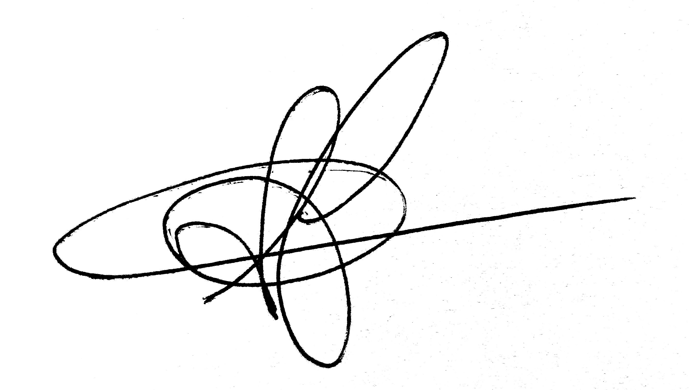
Shawn Flynn,
Locations Manager

